**Tomato**

**F1-D-71 :**

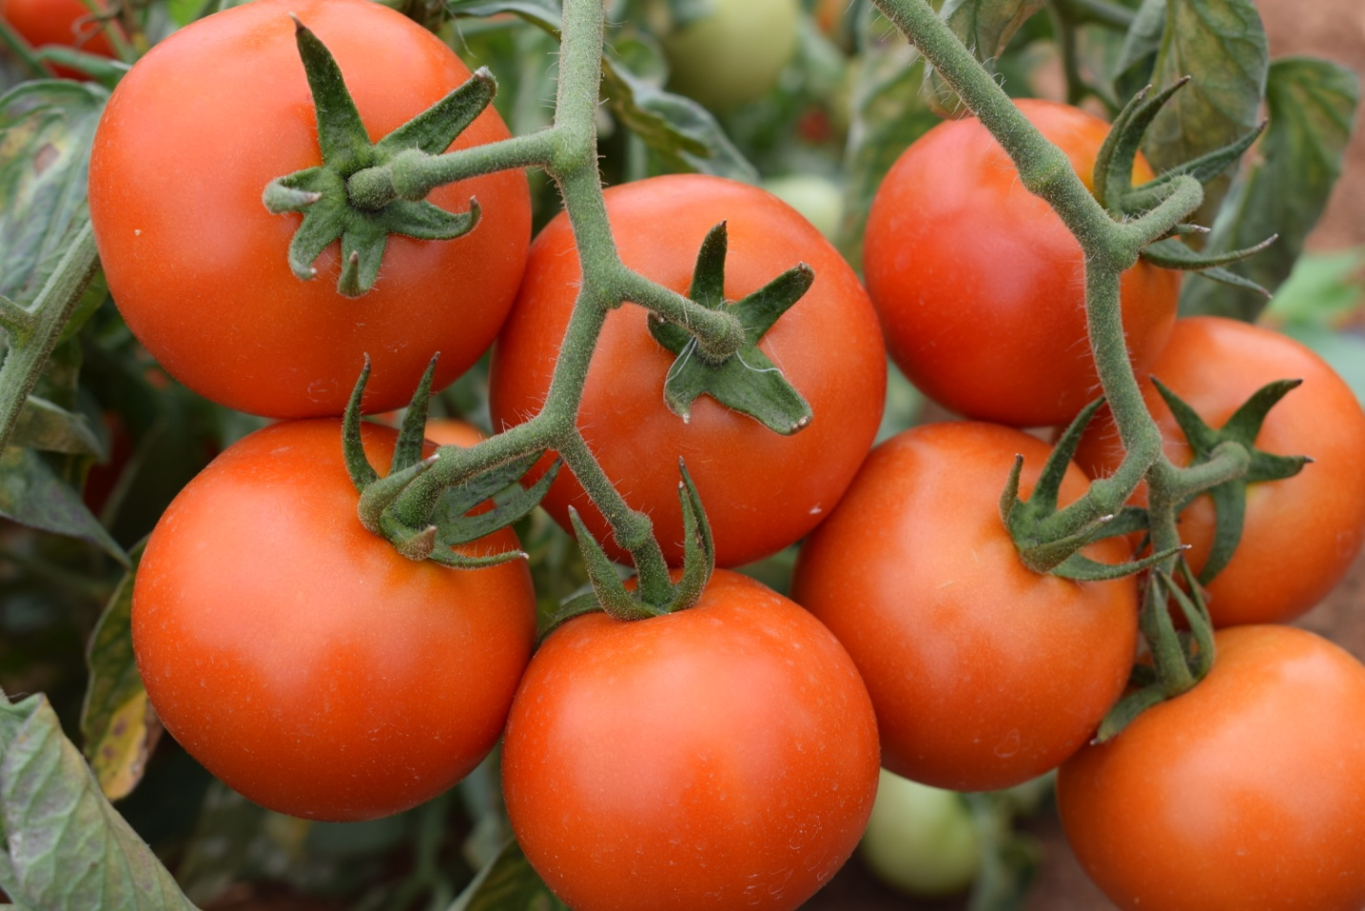

* Plant habit : Semi Determinate
* Day to first harvest: 60-65 days after transplanting.
* Fruit weight :100-110gm
* Fruit shape : Flat-Round
* Remark: good keeping quality, excellent firmness, good keeping quality and suitable for long distance transportation.

**F1-D-82 :**

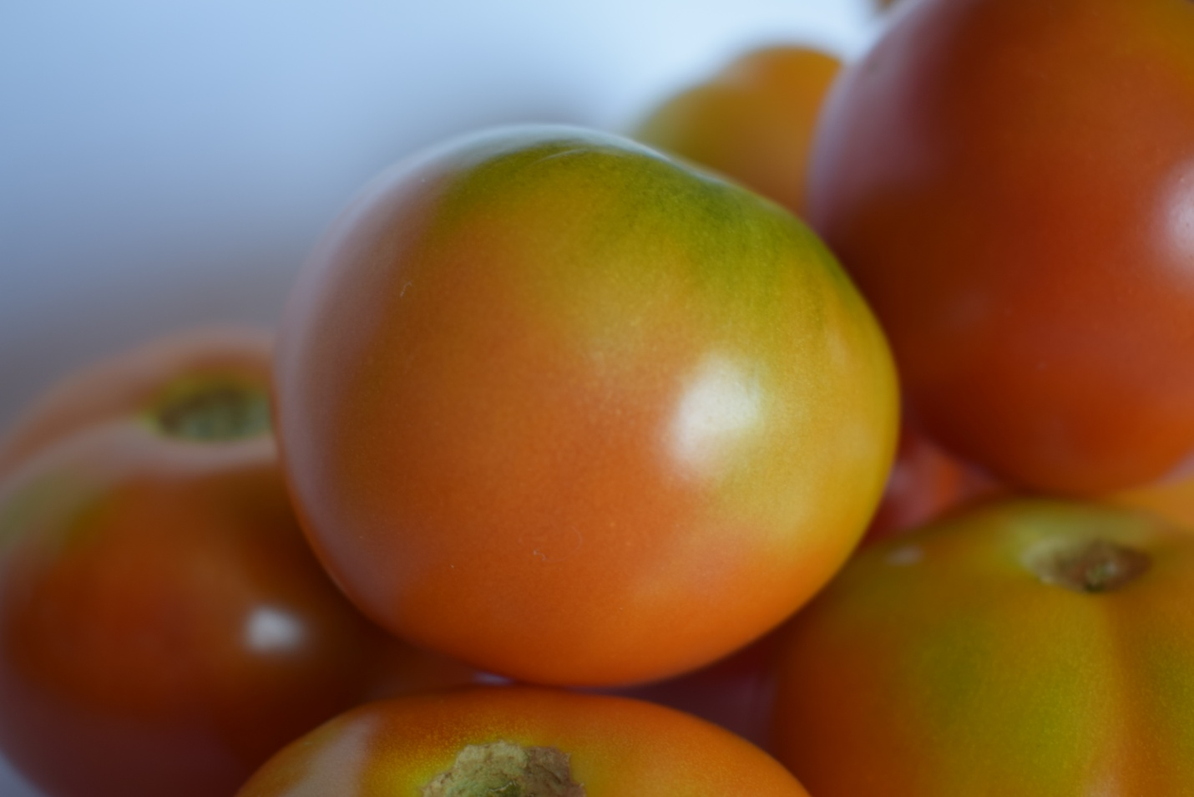

* Plant habit : Semi Determinate
* Day to first harvest: 60-65 days after transplanting.
* Fruit weight: 90-100gm
* Fruit shape: Flat- Round
* Remark: Glossy deep red color, good keeping quality and suitable for long distance transportation.

**F1-D-84 :**

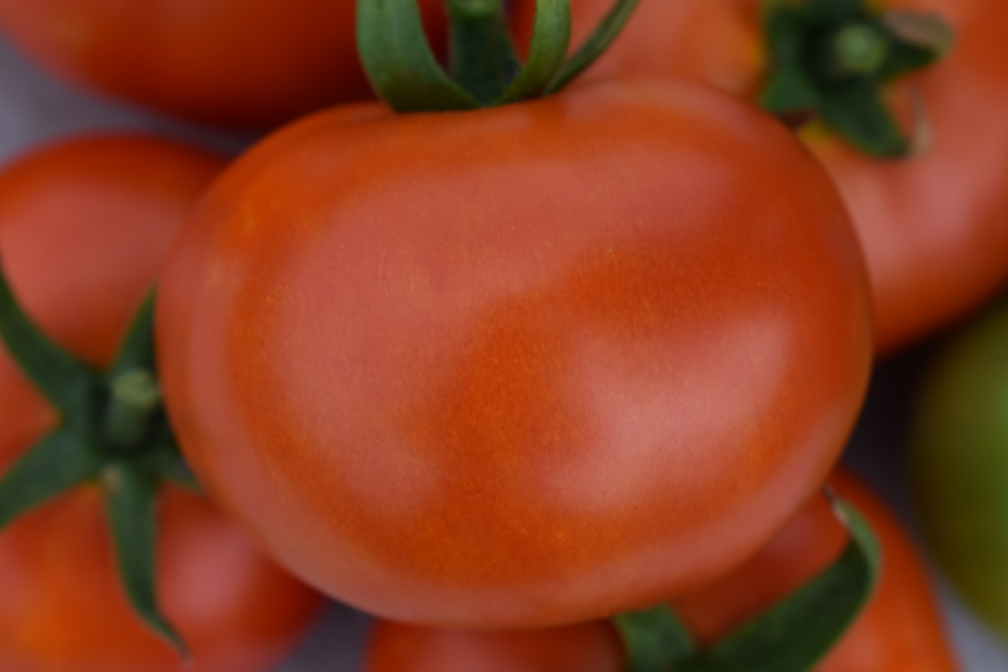

* Plant habit : Semi Determinate
* Day to first harvest : 60-65 days after transplanting
* Fruit weight : 100-110gm
* Fruit shape : Flat-round
* Remark: Bright red color, suitable for medium distance transportation

**F1-D-83:**

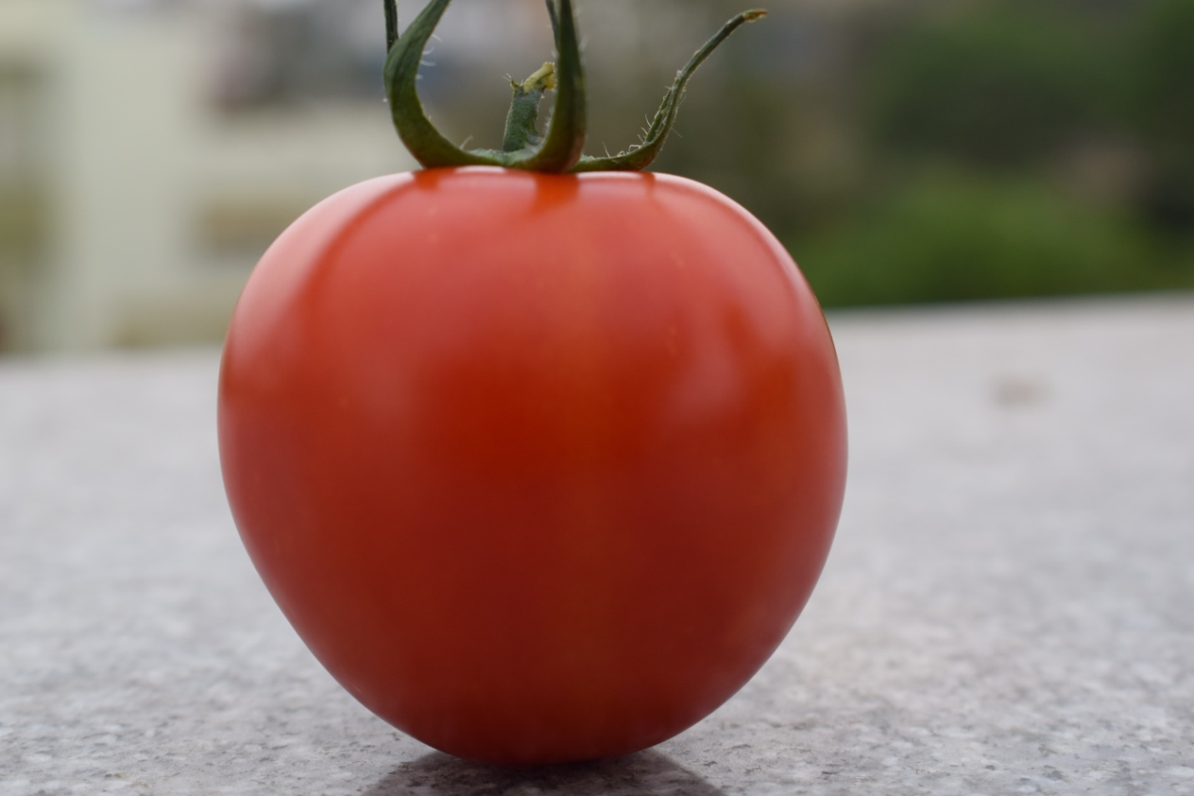

* Plant habit : Semi Determinate
* Day to first harvest : 60-65 days after transplanting
* Fruit weight :100-120gm
* Fruit shape :square round
* Remark: Suitable for long distance transportation

**F1-D-99 (Ratna) :**

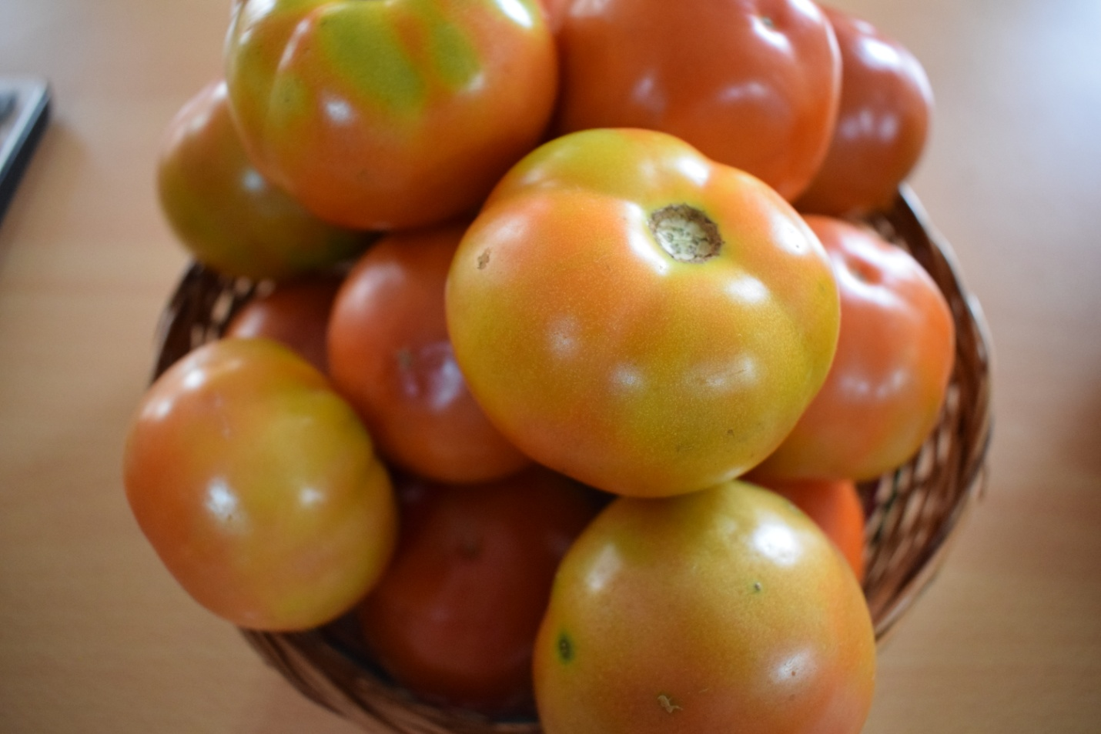

* Plant habit : Semi Determinate
* Day to first harvest : 60-65 days after transplanting
* Fruit weight :100-120gm
* Fruit shape : flat round
* Remark: High yielding hybrid, suitable for long distance transportation.

**F1-D-98 (Sarati) :**

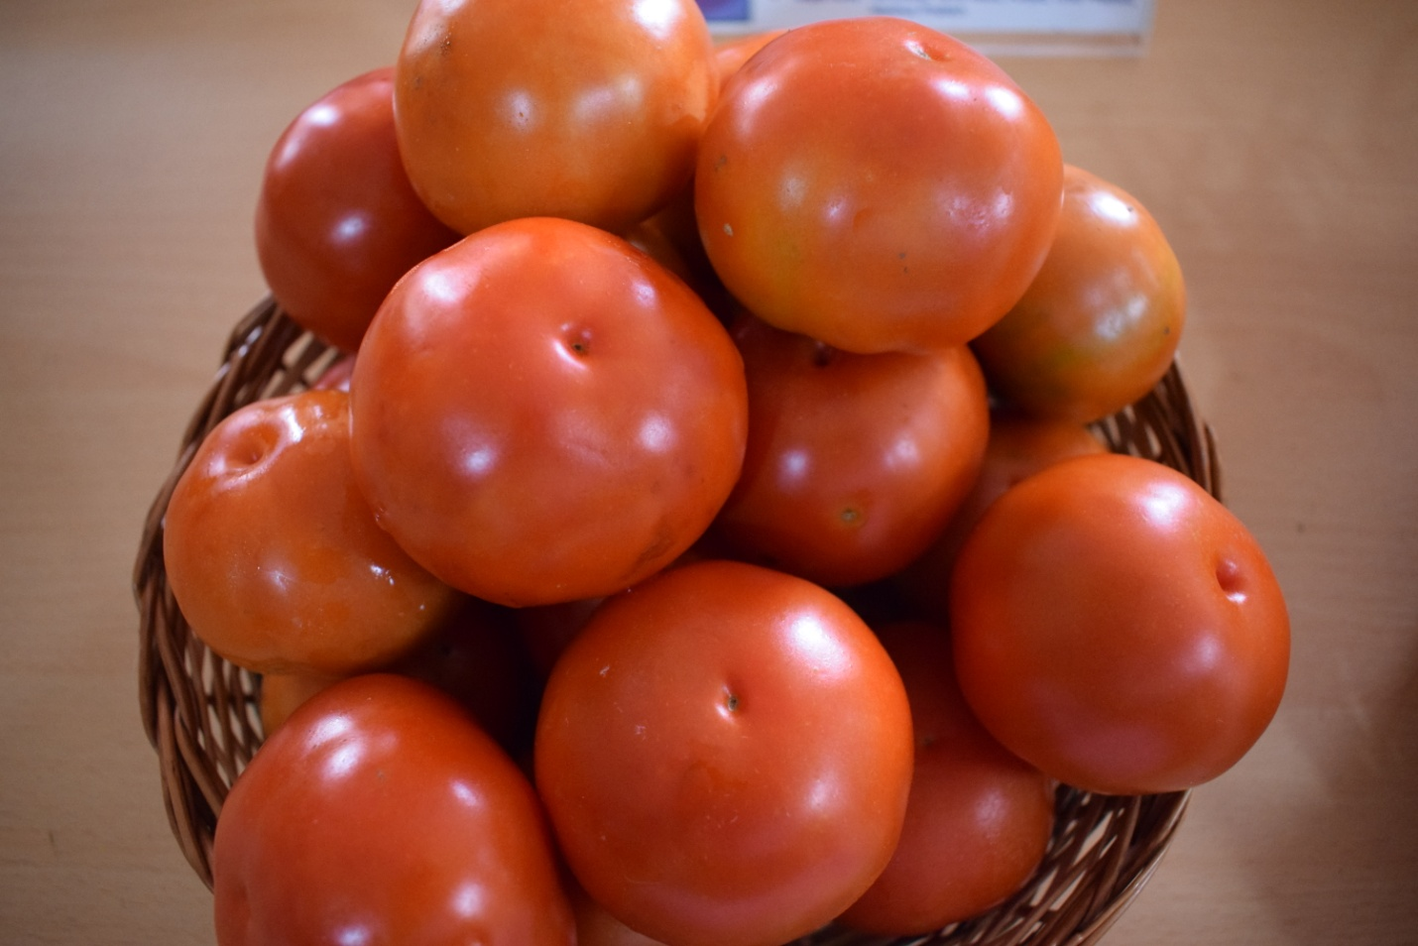

* Plant habit : Semi Determinate
* Day to first harvest : 60-65 days after transplanting
* Fruit weight : 100-120GM
* Fruit shape : Flat-round
* Remark: High yielding hybrid, suitable for long distance transportation

**F1-D-81:**

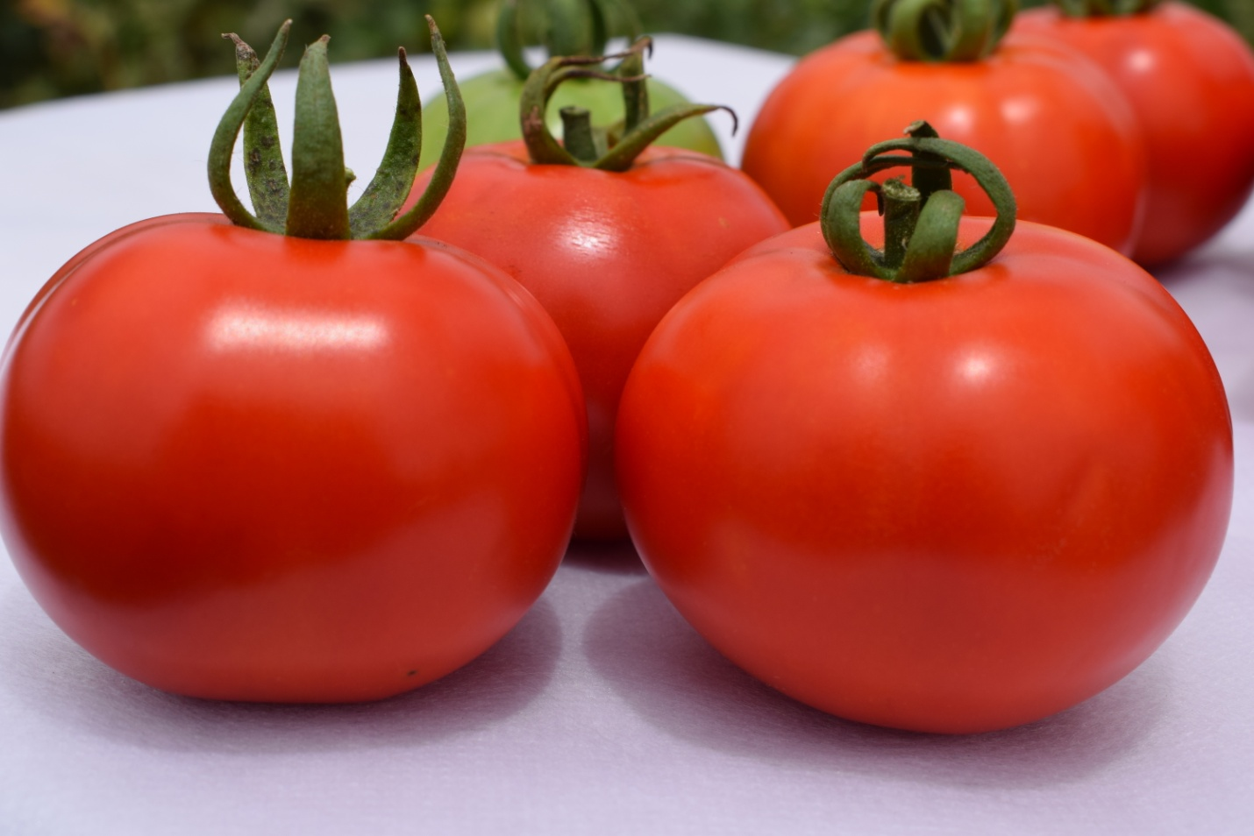

* Plant habit : In- Determinate
* Day to first harvest : 60-65 days after transplanting
* Fruit weight : 120-130gm
* Fruit shape : round
* Remark: Firm fruit, deep red color, suitable for long distance transportation

**F1-D-80**

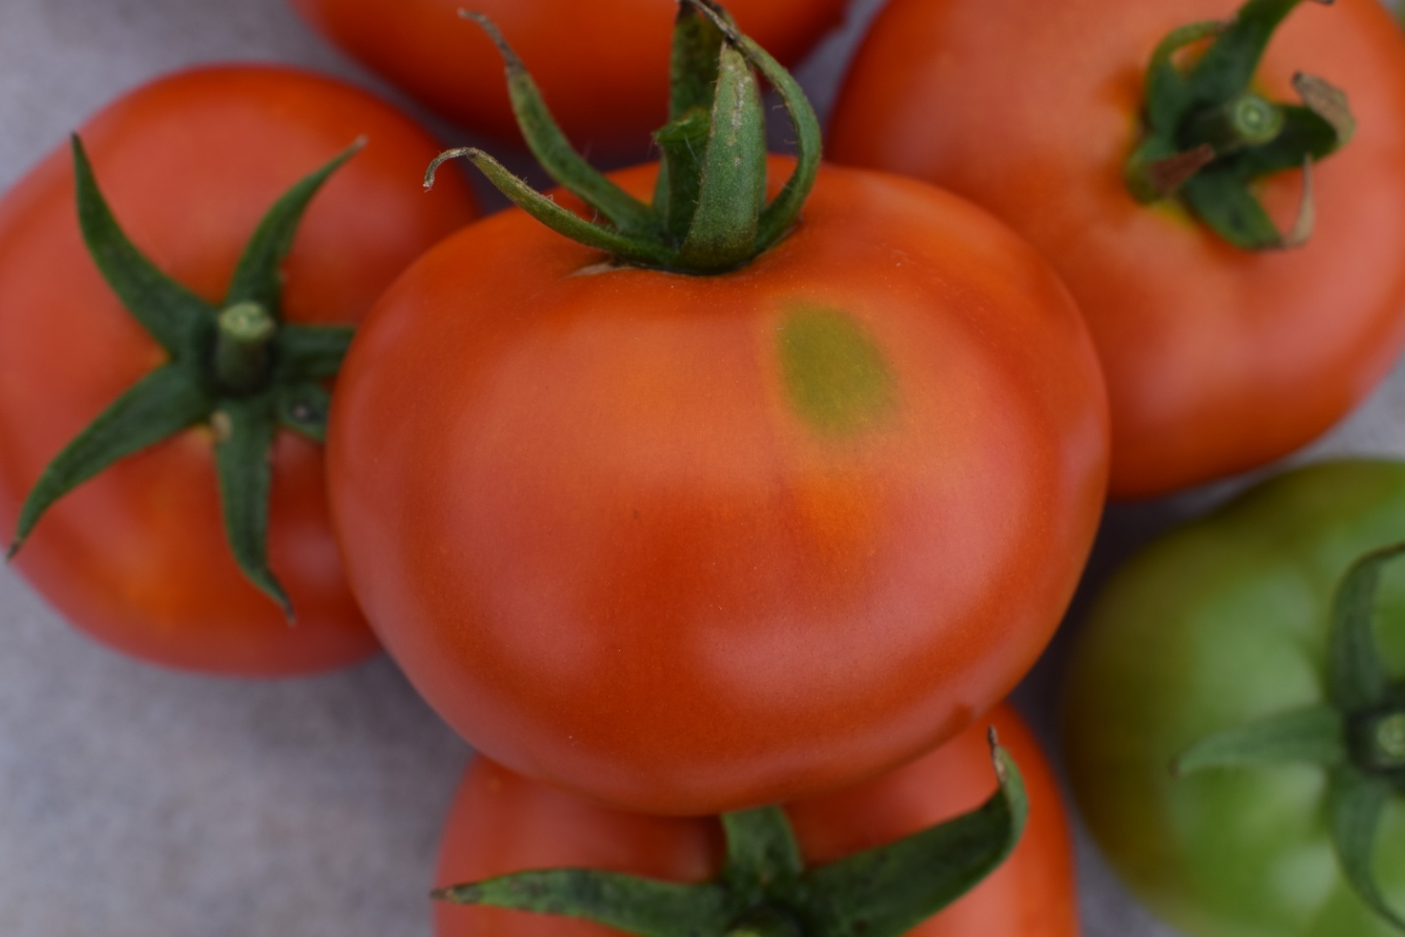

* Plant habit : Semi Determinate
* Day to first harvest : 60-65 days after transplanting
* Fruit weight : 110-120gm
* Fruit shape : round
* Remark: Green shoulder, deep red color, suitable for medium distance transportation

**F1-D-79**

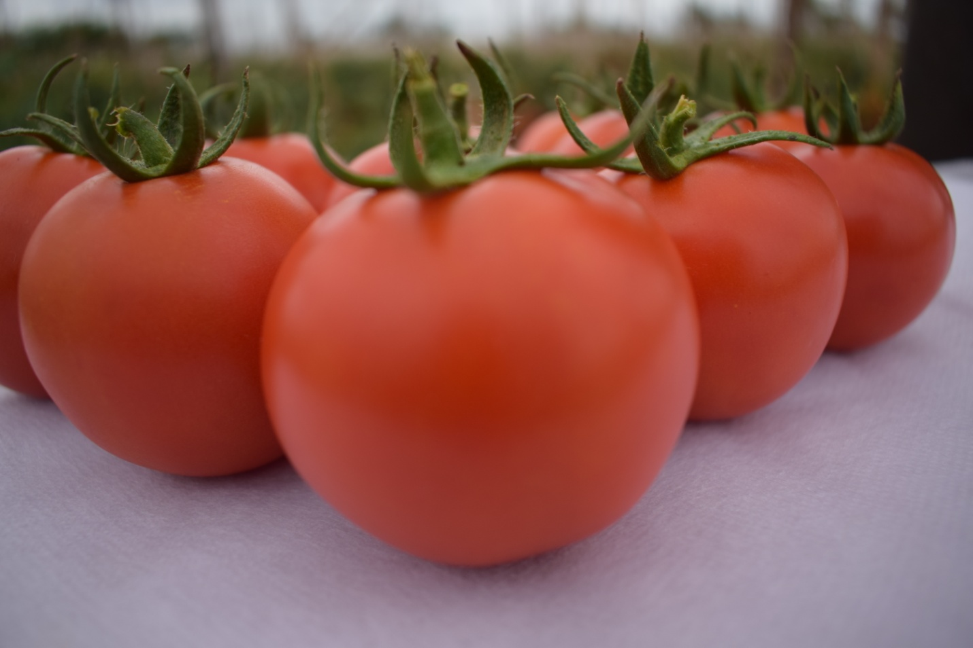

* Plant habit : Semi Determinate
* Day to first harvest : 60-65 days after transplanting
* Fruit weight : 90-100gm
* Fruit shape : round
* Remark: Firm fruit, bright red color, suitable for medium distance transportation

**CROP OKRA**

**F1-D-1011 :**

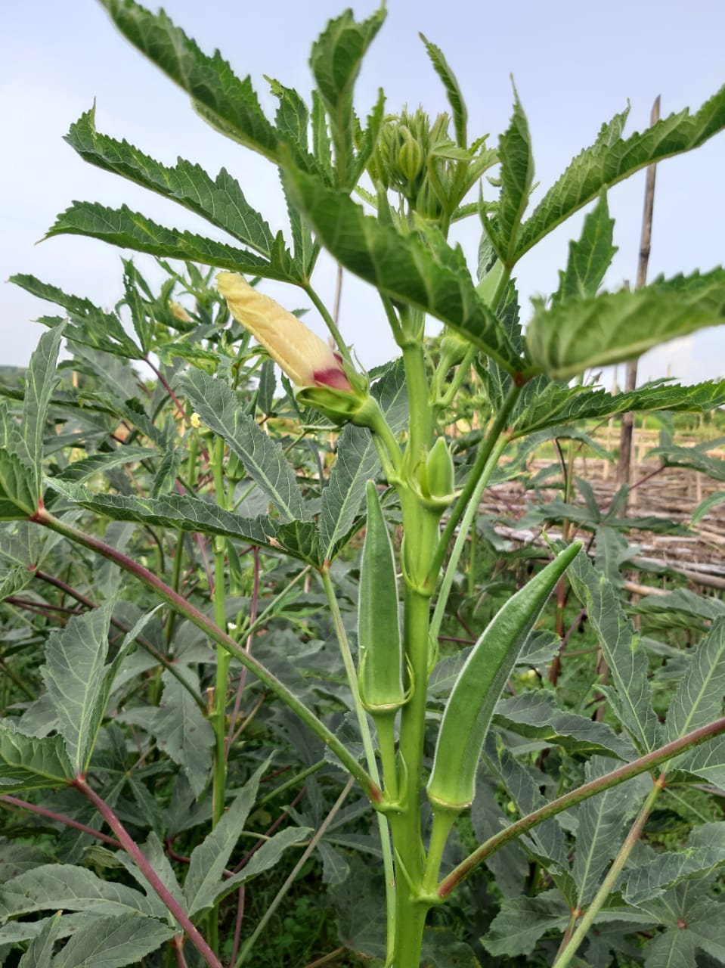

* Plant type : Medium
* First picking :45 to 48 days
* Fruit color: dark green
* Fruit length: 4-5 ft
* No of ridges: 5
* Remark: excellent keeping quality.

**F1-D-1012 :**

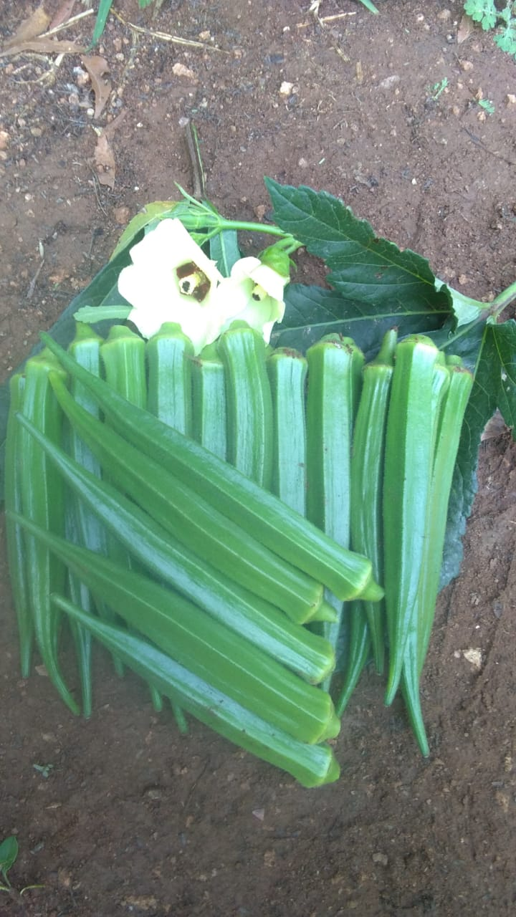

* Plant type : Medium
* First picking :45 to 48 days
* Fruit color: dark green
* Fruit length: 5-6 ft
* No of ridges: 5
* Remark : Tall plant, 3-4 branches, excellent keeping work

**F1-D-1013 :**

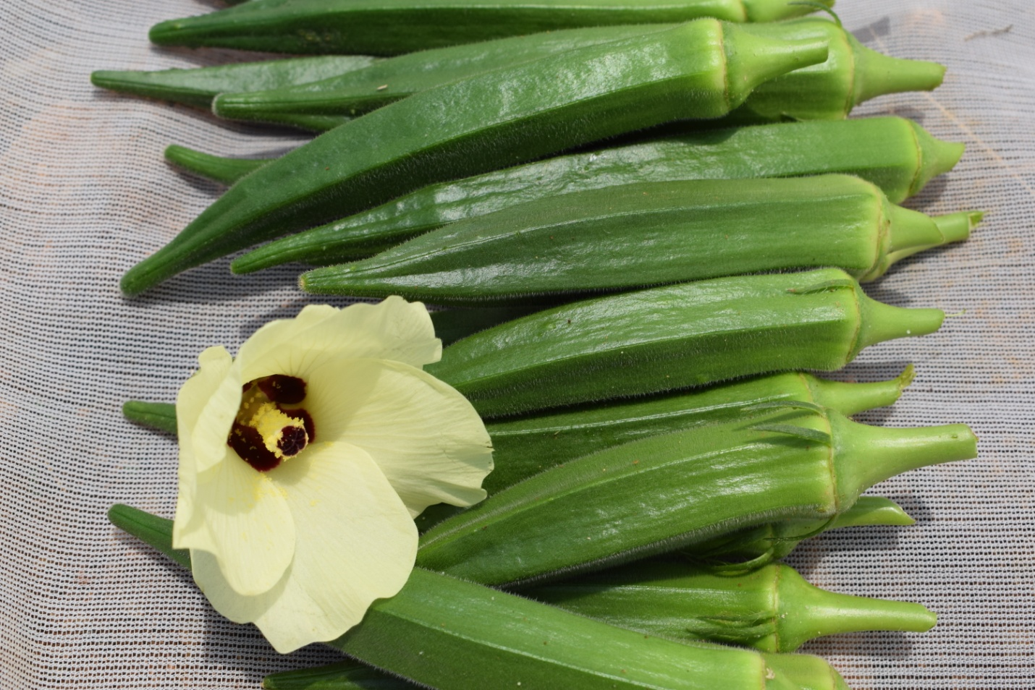

* Plant type : Medium
* First picking :42 to 45 days
* Fruit color: dark green
* Fruit length: 4-5ft
* No of ridges: 5
* Remark : Tall plant, 3-4 branches, excellent keeping work

**CROP CUCUMBER**

**F1-Alfa**

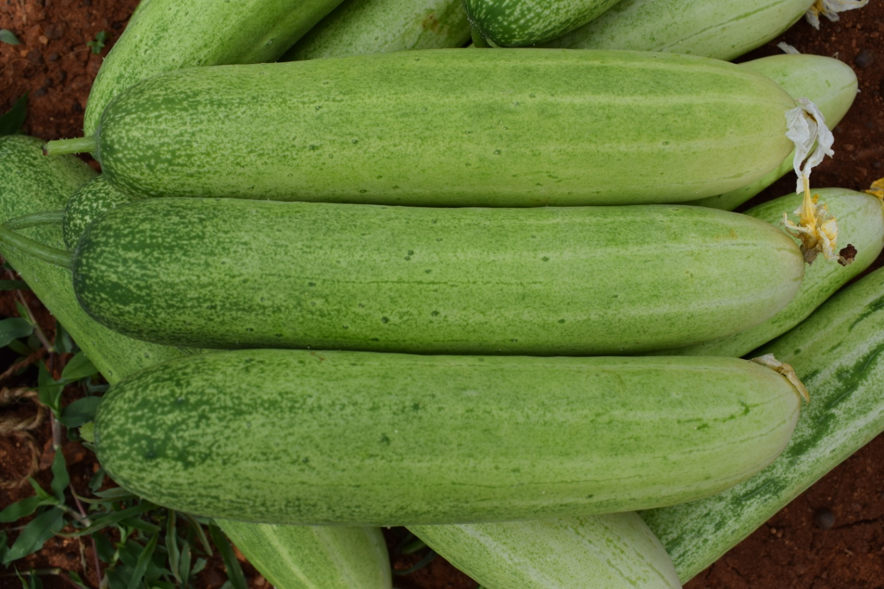

* First picking : 40-45 days
* Fruit shape : cylindrical
* Fruit color: mottle green
* Fruit length: 15 to 18 cm
* Avg. fruit wt.: 150-200 gm
* Remarks: Mosiac tolerant, good keeping quality and suitable for long transportation.

**F1-D-220:**

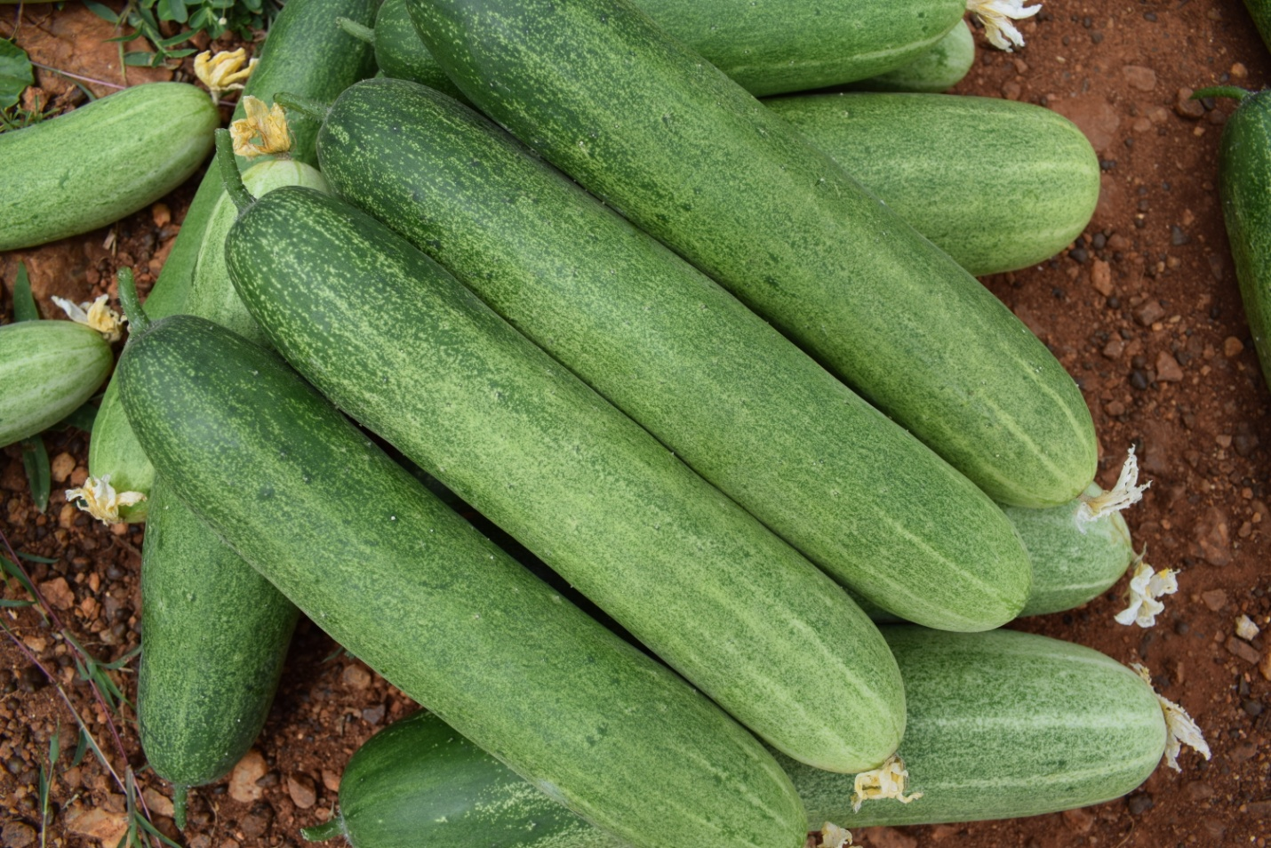

* First picking : 40-45 days
* Fruit shape : cylindrical
* Fruit color: mottle green
* Fruit length: 15 to 18 cm
* Avg. fruit wt.: 150-200 gm
* Remarks: Mosiac tolerant, good keeping quality and suitable for long transportation

**F1-Samba:**

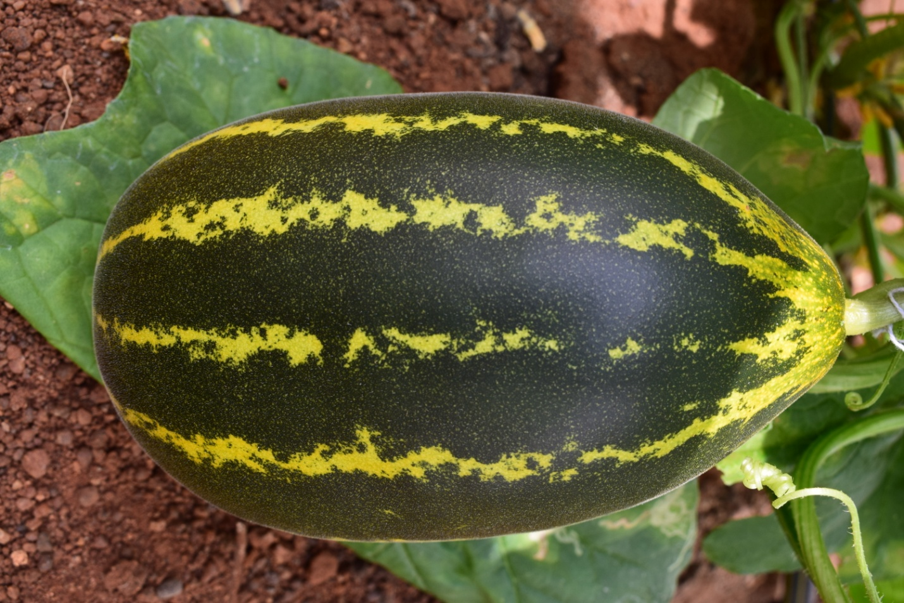

* First picking : 65 days
* Fruit shape : cylindrical
* Fruit color: mottle green
* Fruit length: 15 to 18 cm
* Avg. fruit wt.: 2.0 to 2.5 kg
* Remarks: good keeping quality and suitable for long transportation

**CROP BITTER GOURD :**

**F1-Arman:**

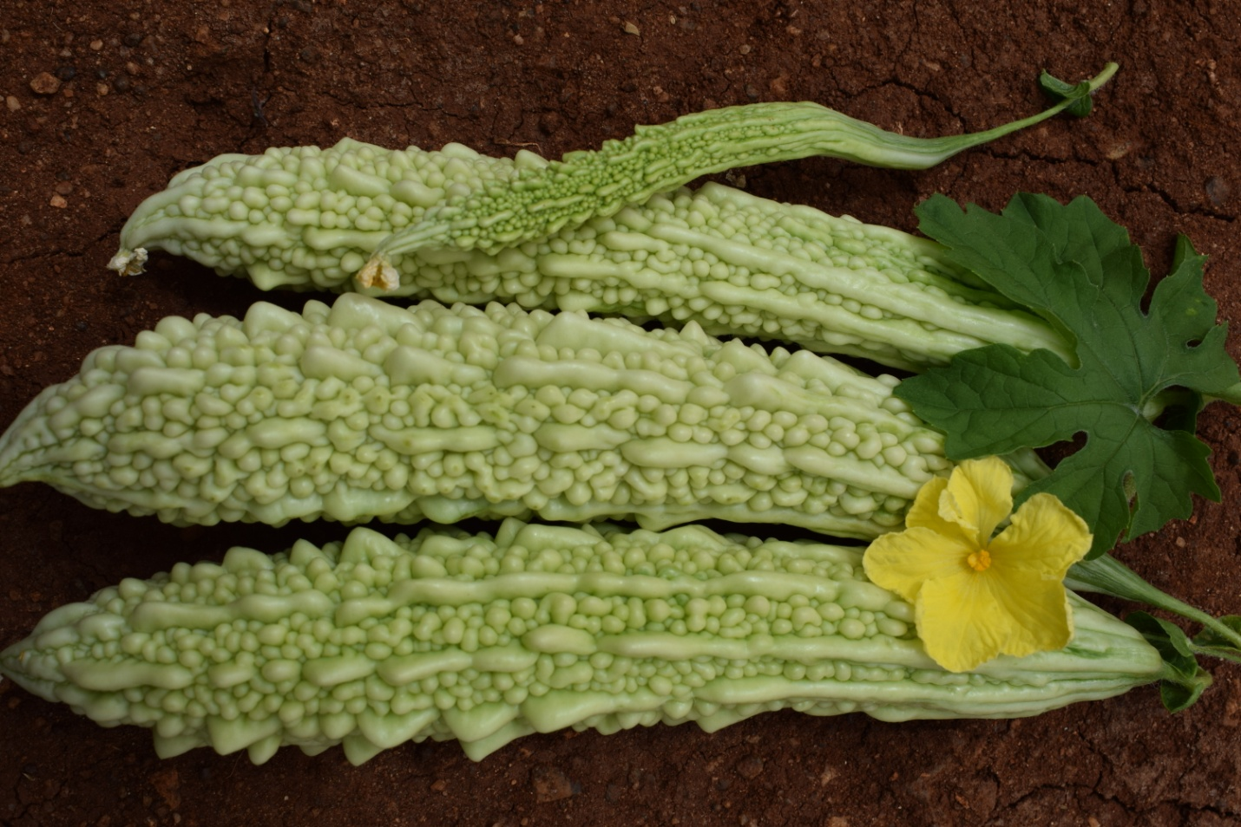

* First Picking : 50-60 days
* Fruit shape :thick medium long prickly
* Fruit Color: white in color with prominent blunt spines
* Fruit Length:25-30 cm
* Fruit avg. weight:175-225 gm
* Remarks: Excellent keeping quality suitable for long transportation

**F1- Mona:**

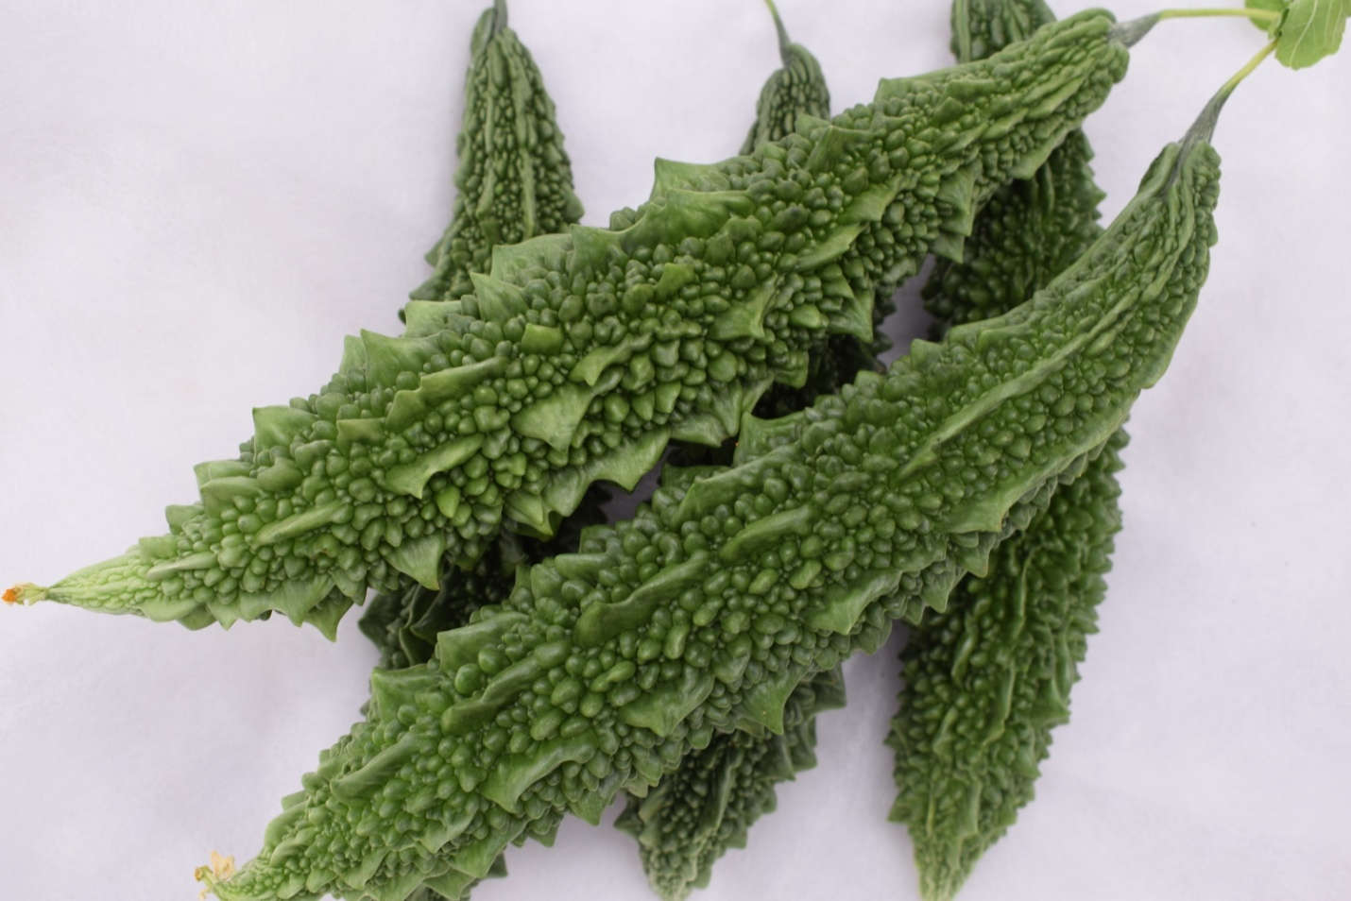

* First Picking : 50-60 days
* Fruit shape :thick medium long prickly
* Fruit Color: dark and glossy green, blunt spines.
* Fruit Length: 15-18
* Fruit avg. weight: 150-200 gms.
* Remarks : Excellent bearing capacity, good keeping quality suitable for long transportation

**CROP HOTPEPPER**

**F1-D-540**

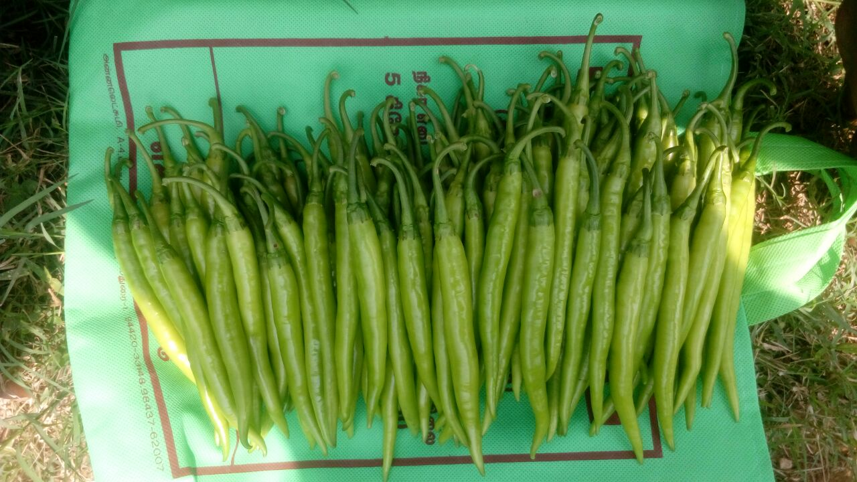

* Plant habit: Intermediate plant
* First picking:60-65 days
* Fruit color: Shiny light green.
* Fruit length:12-14 cm
* Fruit diameter:1.5cm
* Fruit pungency: medium pungent
* Remark :good productivity for fresh market

**F1-D-551**

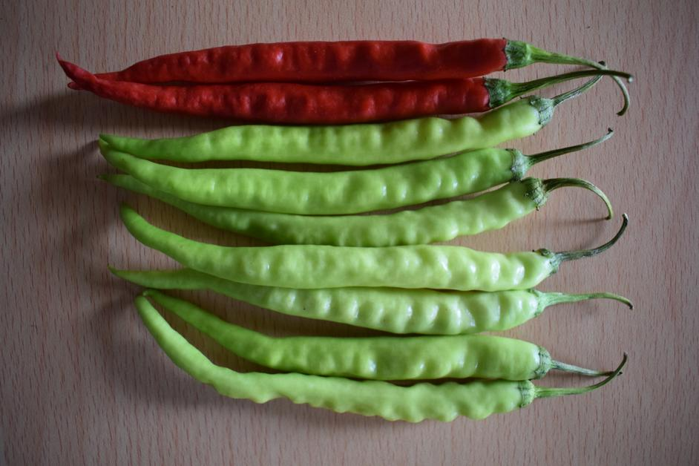

* Plant habit: Intermediate plant
* First picking:60-65 days
* Fruit color: Shiny yellowish green.
* Fruit length:14-18cm
* Fruit diameter:1.2 cm
* Fruit pungency: medium pungent
* Remark :good productivity for fresh market

**F1-D-545:**

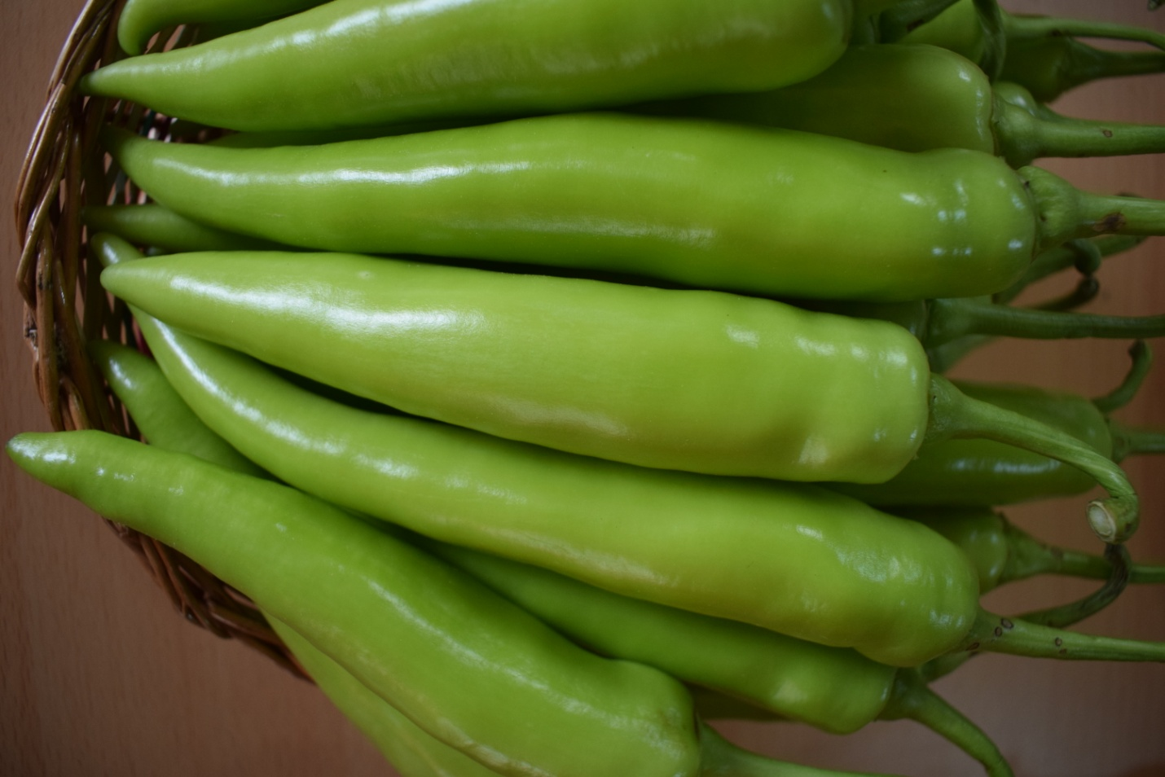

* Plant habit: Tall plant
* First picking:60-65 days
* Fruit color: glossy yellowish green.
* Fruit length:14-18cm
* Fruit diameter:2.0 cm
* Fruit pungency: medium pungent
* Remark: good productivity for fresh market/ Bajji segment.

**F1-D-543:**

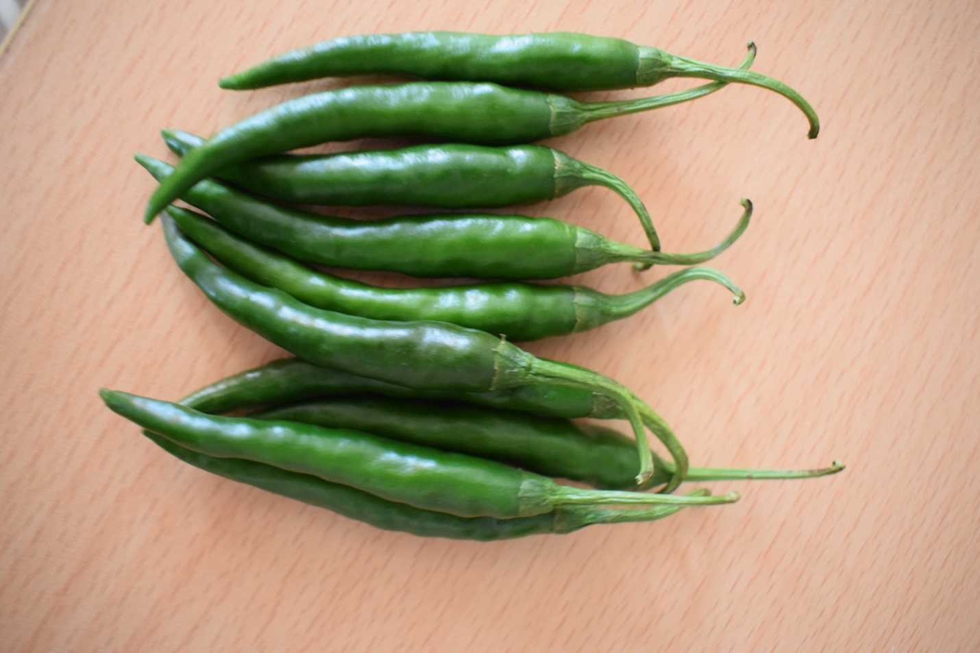

* Plant habit: Compact plant
* First picking:60-65 days
* Fruit color: Dark Green
* Fruit length:5-7 cm
* Fruit diameter:1.0 cm
* Fruit pungency: medium pungent

**F1-D-535 :**

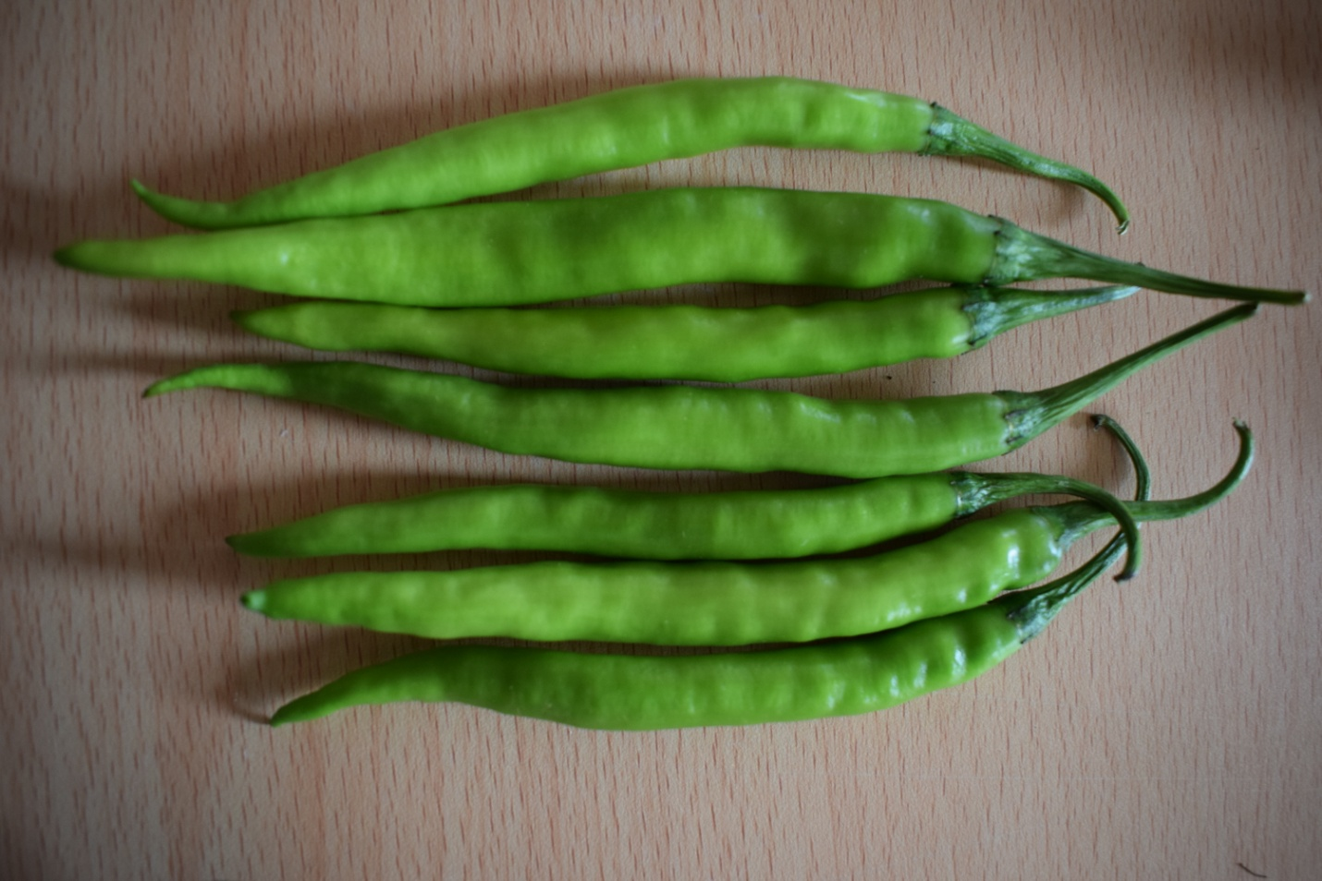

* Plant habit: Strong plant
* First picking:60-65 days
* Fruit color: Medium green
* Fruit length:14-16cm
* Fruit diameter:1.2cm
* Fruit pungency: medium pungent
* Remark: Excellent for fresh market.

**CROP RIDGEGOURD:**

**F1-Naman:**

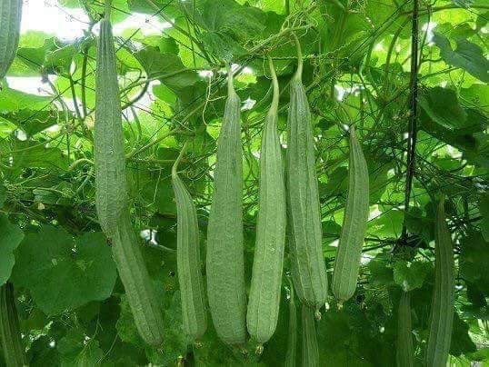

* First picking : 45-50 days
* Fruit shape: long straight
* Fruit color: light green
* Fruit length:35-45cg
* Fruit Av wt:400-500 g
* Remarks: very healthy vigorous creeper

**F1-Gaja:**

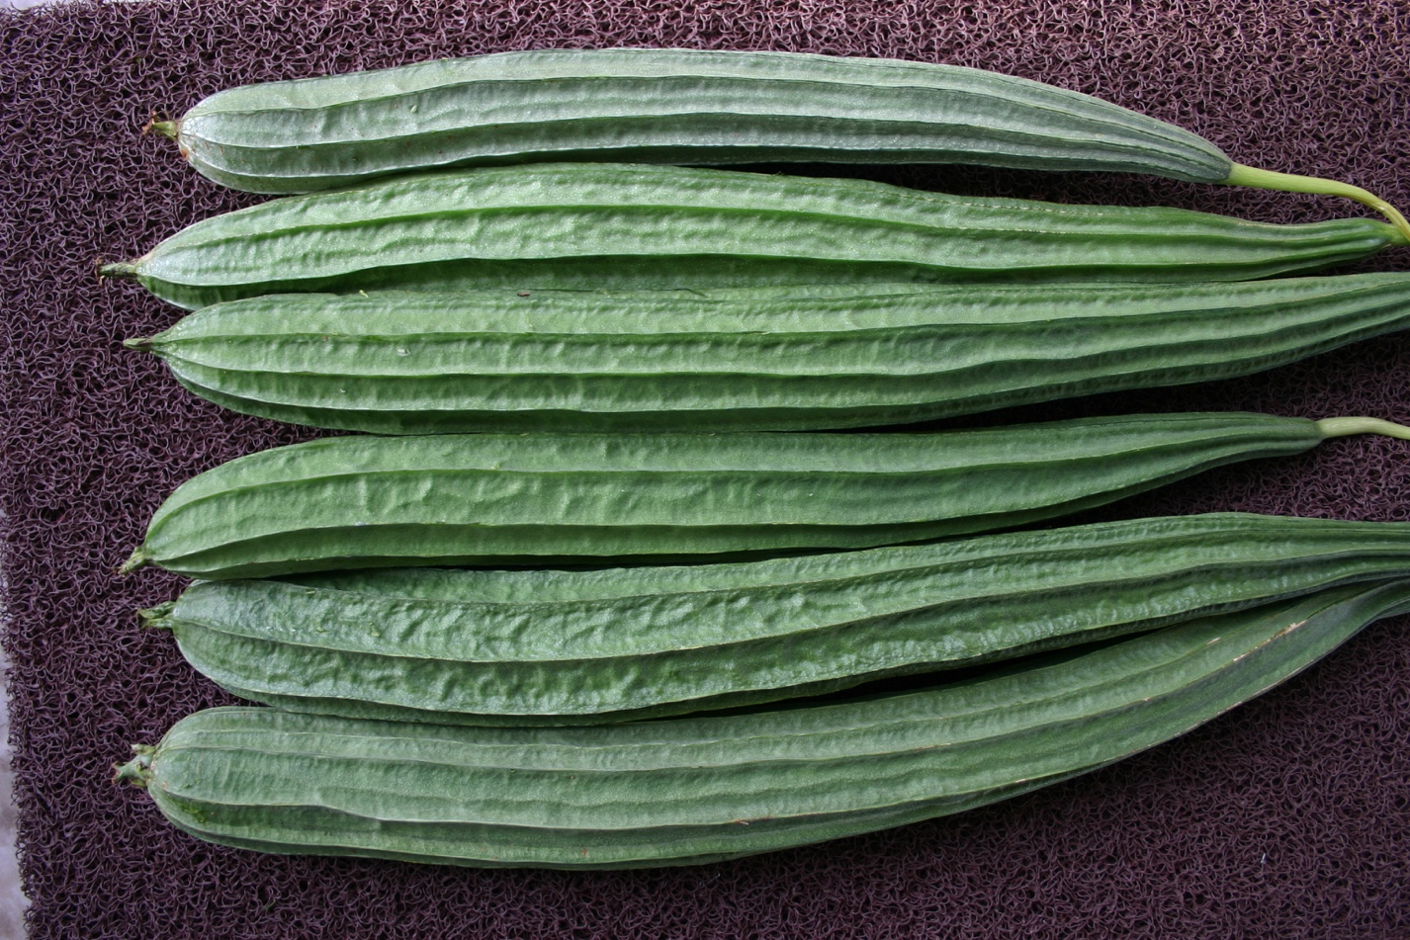

* First picking : 45-50 days
* Fruit shape: long straight
* Fruit color: Medium green
* Fruit length: 45-55 cg
* Fruit Av wt:500-600g
* Remarks: very healthy vigorous creeper

**CROP BOTTLEGOURD:**

**F1- Varsha:**

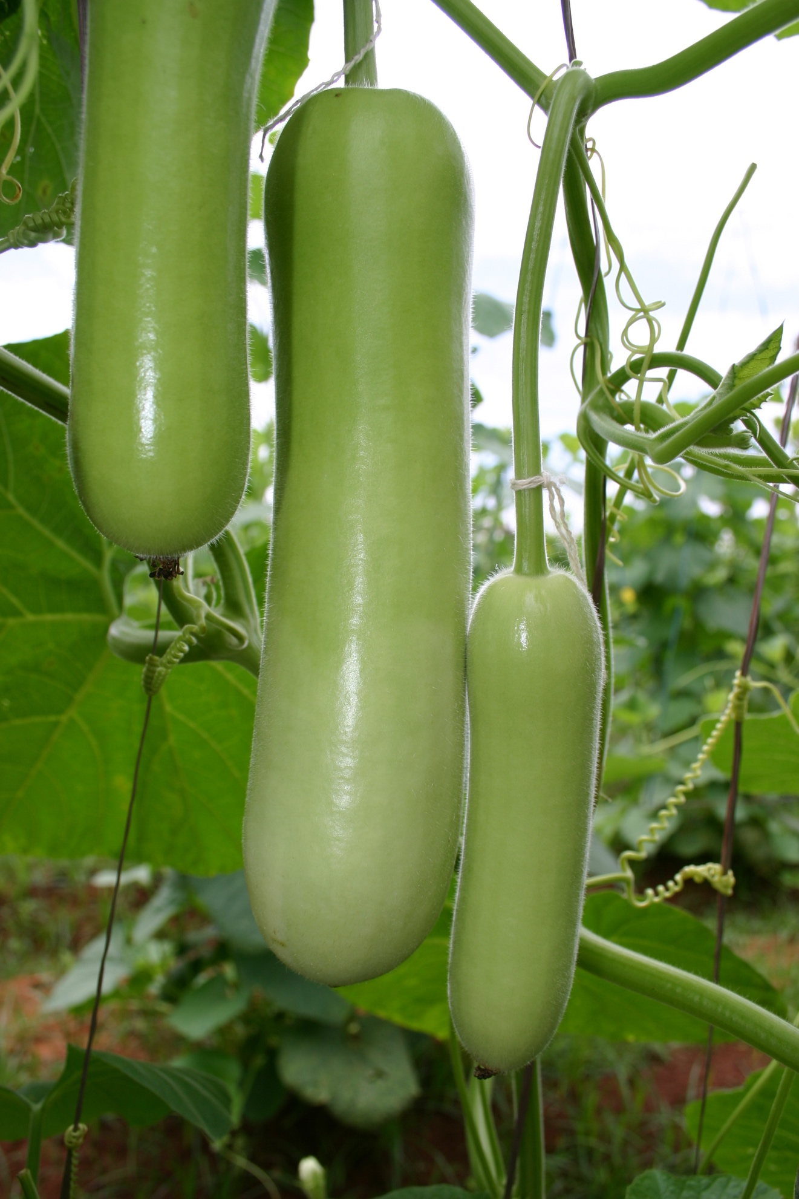

* First picking: 50-55days
* Fruit shape: Straight Cylindrical
* Fruit color: light green
* Fruit length: 28-30 cm
* Fruit Av wt: 600-800gm
* Remarks: excellent keeping quality.

**CROP WATERMELON**

**F1 – Salman:**

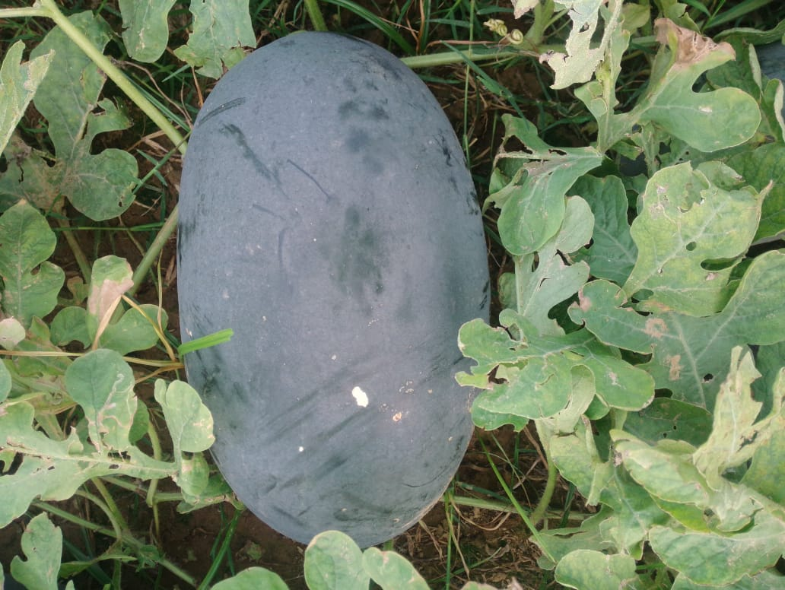

* Maturity days : 85-90 days
* Fruit shape : big oblong
* Fruit surface: dark green
* Fruit flesh color: red with crispy texture
* Fruit avg. wt :3.5-4.5 kg
* Remarks: excellent keeping quality, suitable for long transportation

**F1-Rocky**

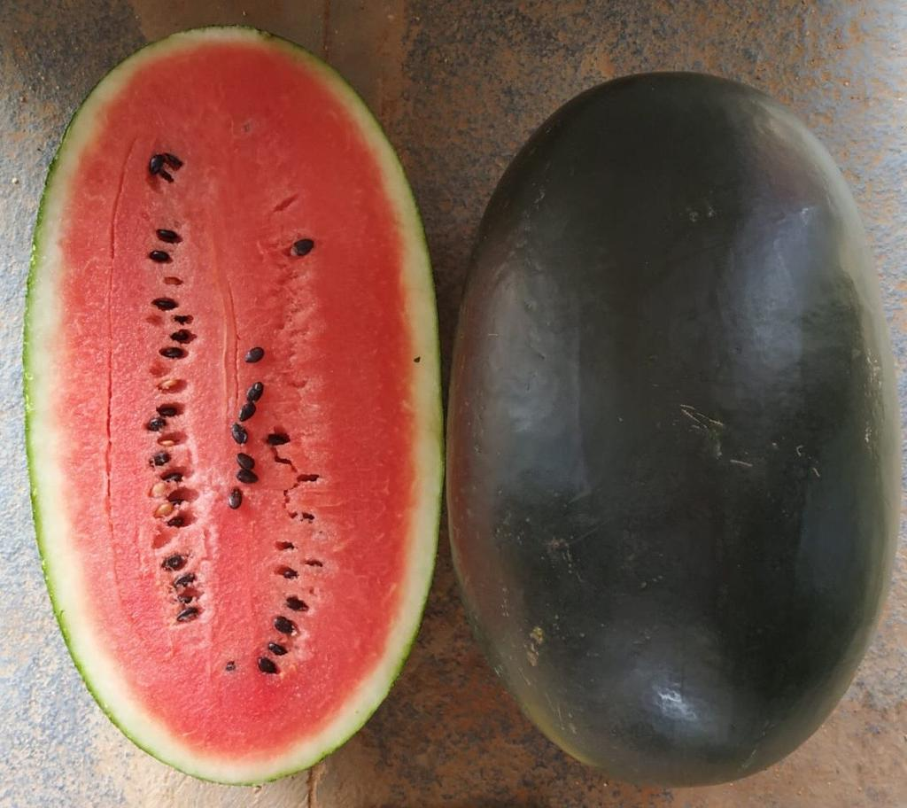

* Maturity days : 85-90 days
* Fruit shape : Square shape
* Fruit surface: dark green with tough rind
* Fruit flesh color: red with crispy texture
* Fruit avg. wt :3.5 – 4.0 kg
* Remarks: excellent keeping quality, suitable for long transportation